HTML:

1. If i want to display data like below:

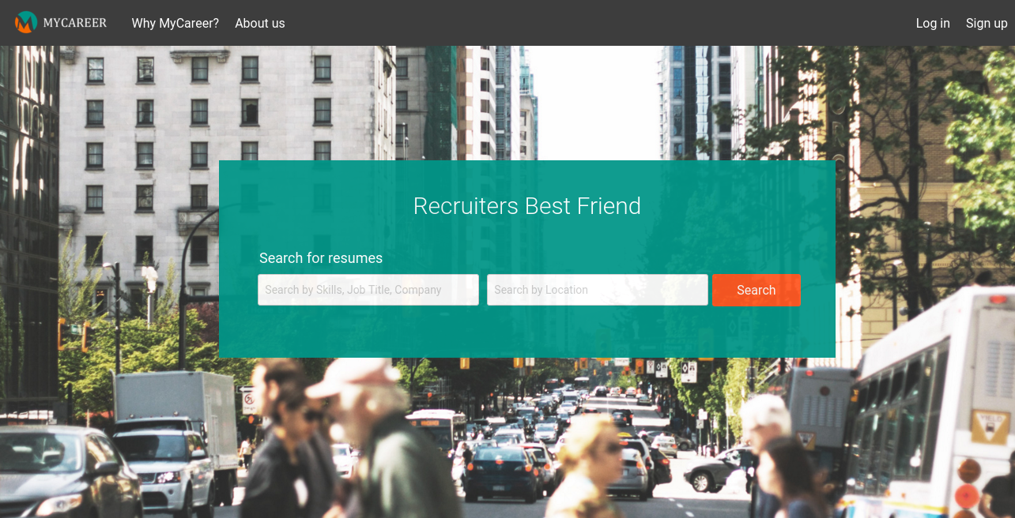

* 1. It have tag to connect to other applications.
  2. Awesome look.
  3. It will allow us to enter email to get notifications from them.
  4. Have an option to select language.

1. Title tag used to identify the tabs and can be use to show the company logo.
2. We have out html content ready. But it is not looking good. So i want to change my text representation little better as like the text in the picture above. We cant make it completely like that we have some text formatter to change the text to italics, bold and underlines etc...
3. So far we are dealing with simple web documents. I want to represent the document in such a way that, i want to split it into different sections or components (react word) or blocks.
   1. **section** – Used for grouping together thematically-related content. Sounds like a div element, but it’s not. The div has no semantic meaning.
   2. **aside** – Used for tangentially related content. Just because some content appears to the left or right of the main content isn’t enough reason to use the aside element.
   3. **header** –
   4. **nav**– Intended for major navigation information. A group of links grouped together isn’t enough reason to use the nav element. Site-wide navigation, on the other hand belongs in a nav element.
   5. **footer** –
   6. ***dialog*** - tag defines a dialog box or window. The <dialog> element makes it easy to create popup dialogs and modals on a web page.
   7. ***Figure*** - specifies self-contained content, like illustrations, diagrams, photos, code listings, etc.

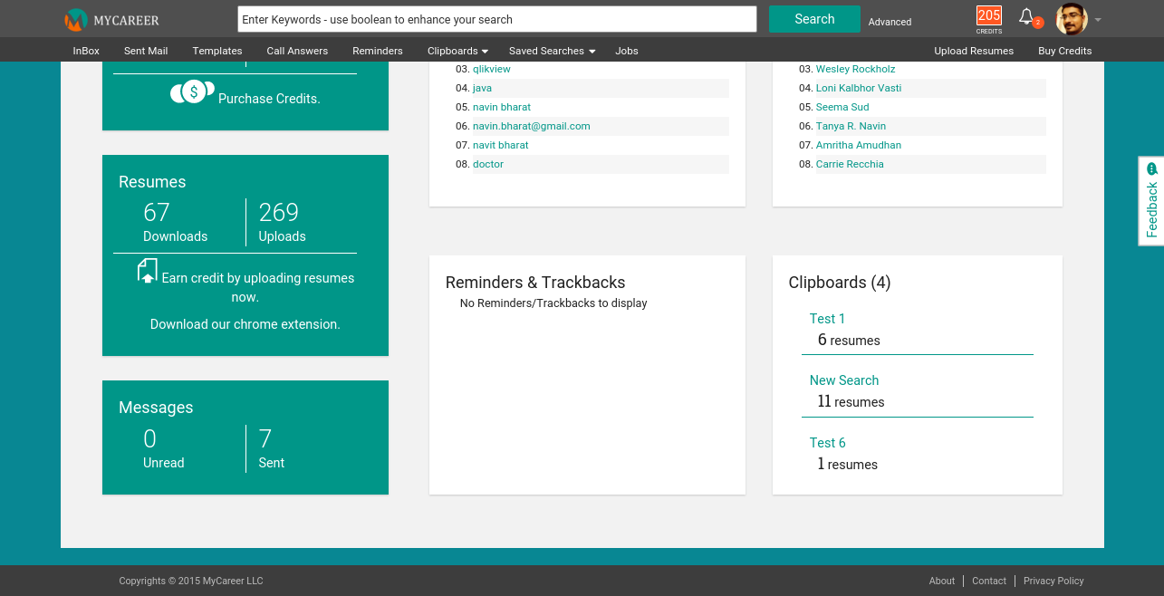

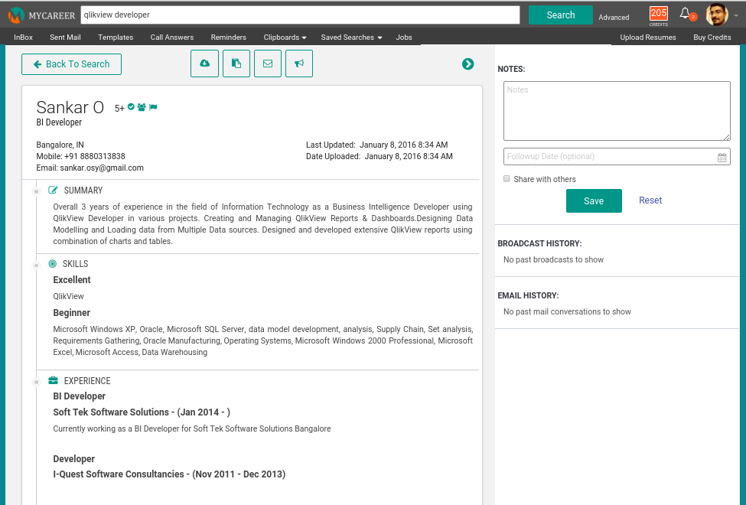

1. Tables are use to represent data in a tabular format like:

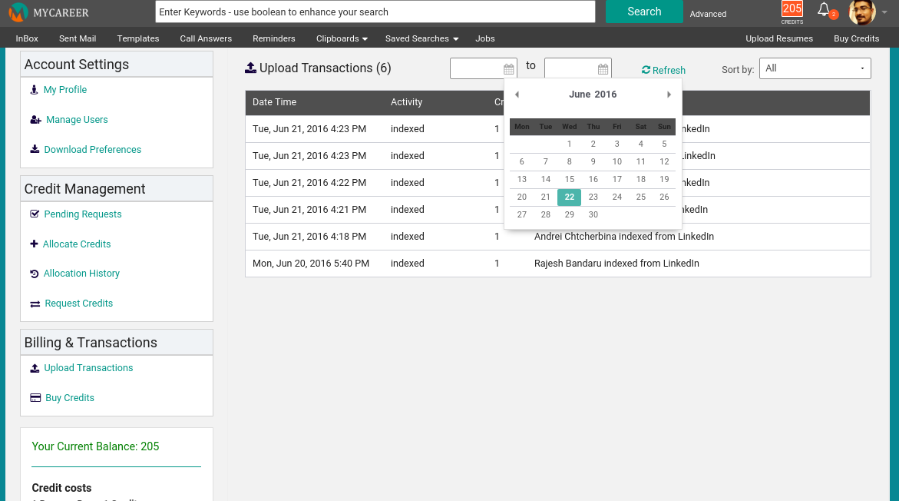

1. I have lots of information on my page and it have to redirect to the corresponding content automatically on a single click. So i use anchor tags to represent entire data in a single page. If I click on one of the tags, it will fetch the data from the document which is associated with it.



1. Some times we have to alert the user before doing some action like conformation from the user to delete the mails from the inbox or check mark to the privacy policy while using the software.

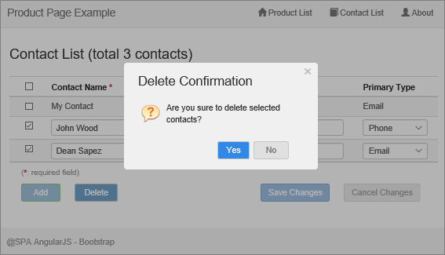

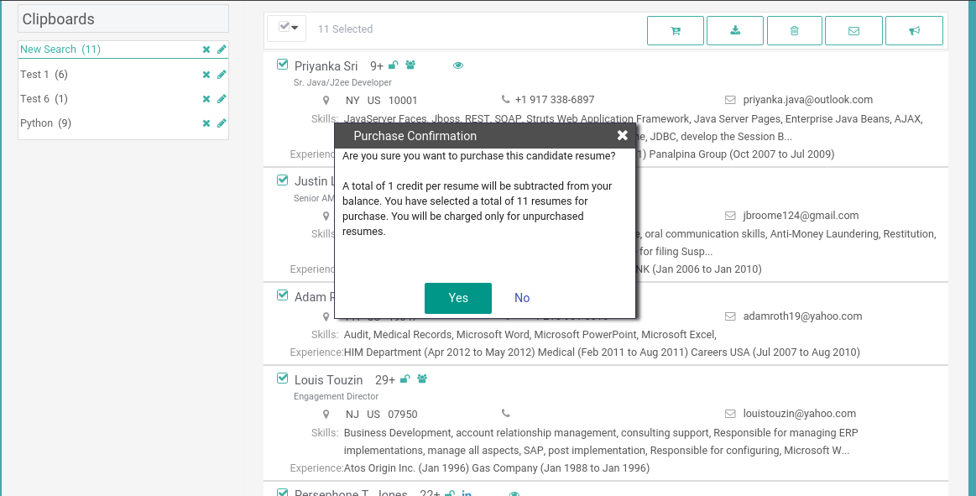

1. Some times we need to capture the user information or need to take feedback from the user for improvement of our product. That must be like user can enter any text information or have a dropdown to chose the option or can select multiple options from the list of items. After all it allow us to submit the information.

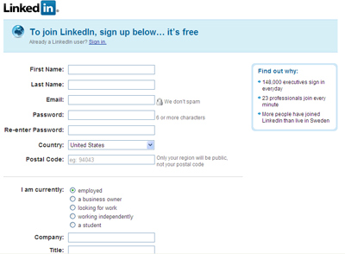

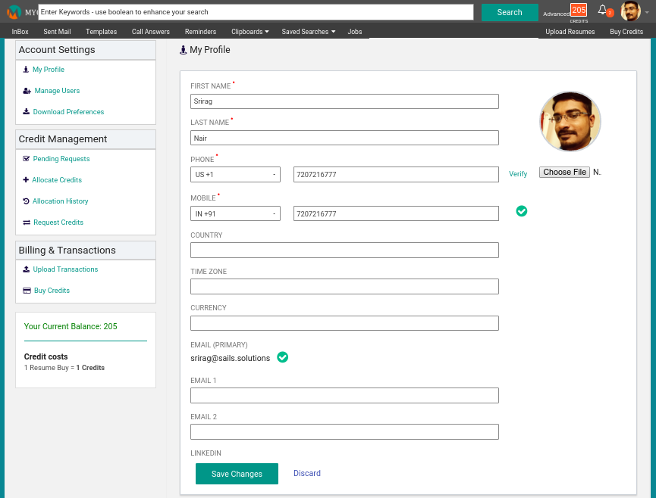

1. Some times we have to represent list of information like an index. Where all the information is represented as listed items. For example, i am creating a e book. Where in the index we have to represent entire list of book content as like the normal text books. In order to do that we use order list and unordered list. In some cases like linked in header, the header menu can also be created using unordered list.

